SECONDARY MEASURE MSDWT MUSIC 6-12

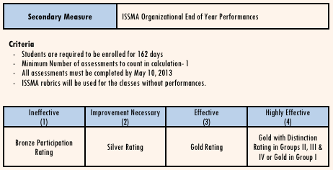

Teacher Name
Class/Ensemble entered in the ISSMA Organizational Contest
Date of ISSMA Organizational Contest
Group level entered | IV III II I  (circle one)
Rating received | Bronze/Participation Silver  Gold!! Gold with Distinction  (circle one)

Upload this form along with your ISSMA Organizational judges sheets to OwnIt!

Teacher Signature:_
Date:_

